**How to login the Linux Instance in window’s machine –**

1. Open the AWS console & select the instanced & go to connect

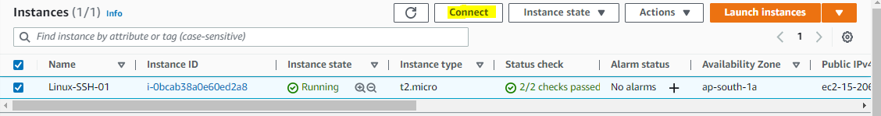

In Connect – EC2 Instance Connect Tab – Just lick connect

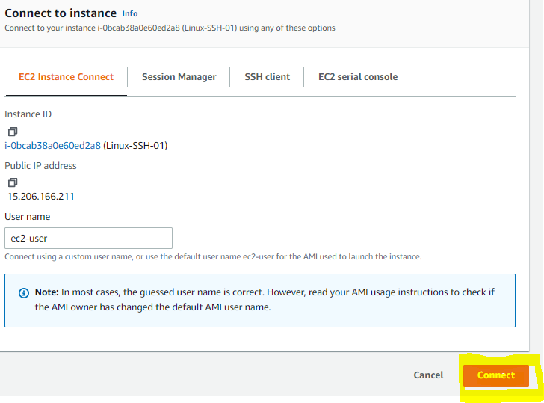

You connect the Instance from the AWS console direct –**ec2-user**

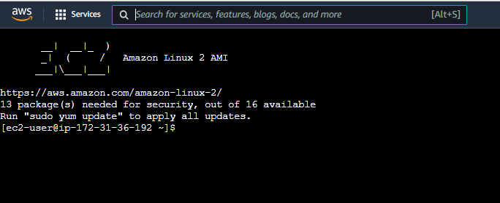

1. Open the PowerShell in windows machine

Now copy the public key from the saving source to system documents

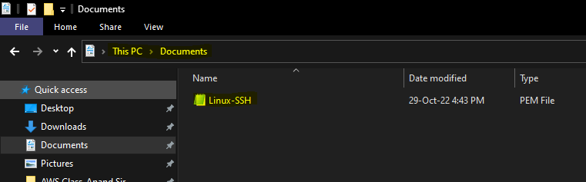

Now Go to connect option select the SSH client tab & copy the Example from the Instance ID

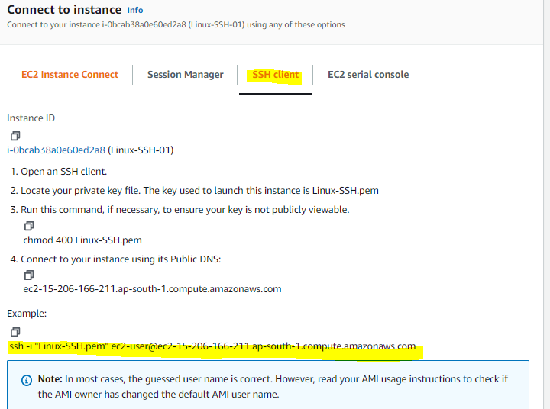

Now Open the PowerShell in windows machine

Go to documents directory with cd documents



Then paste the example in PowerShell

It will have asked you to login yes/no—press yes & Enter – You will login the **ec2-user**

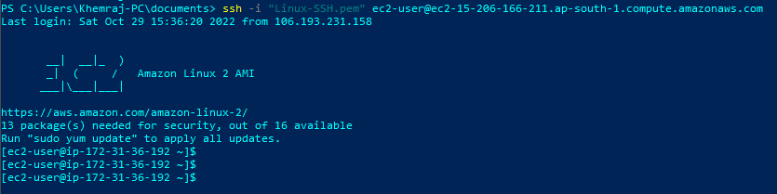

1. Login from the putty application

Go to Putty gen & generate the. ppk public file & saved in safe place (key folder)

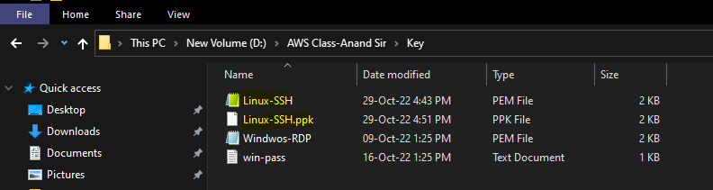

Open the Putty app & copy the public IP - PublicIPs: 15.206.166.211

Then go to Connection tab – SSH- Auth & gives the .ppk file path ---Click Open

Its asked your login (Accept)----------------------**ec2-user**

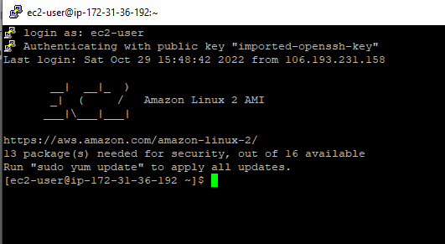

1. Open the cmd & type ssh

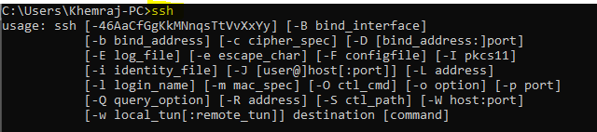

After that go to public key file directory (.pem)



Now past the below command

**ssh -i** **C:\Users\Khemraj-PC\Documents\Linux-SSH.pem** [**ec2-user@15.206.166.211**](mailto:ec2-user@15.206.166.211)

That is ssh –i ****************.pem file path ---username@Public IP

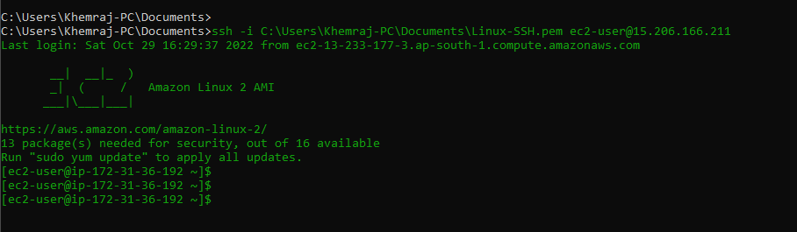

1. Open the Windows terminal & follow the same steps as windows PowerShell.